Evaluating Web Sites

Students review one of the excellent VIDEO tutorials which outline how to decide whether information you find on a web site is likely to be reliable and useful for academic research, or not. Ideally #E52 could be reviewed before class time, and #E53 at the beginning of class:

Credible Sources Count Tutorial (usefully used individually)
http://library.acadiau.ca/tutorials/webevaluation/
This is an excellent introduction to evaluation of websites using cartoons, web examples, interactive inquiry and questions. Introduces an evaluation strategy for students to follow. A couple of web sites to review are blocked in the UAE, but this doesn’t detract from the value of this tutorial. Produced by Vaughan Memorial Library, Canada. Tutorial takes approx. 10 min.
Resource #E52 in the HCT Student Research website.

Evaluating Websites (usefully used either individually or as a group)
https://www.youtube.com/watch?v=aem3JahbXfk
A short cartoon-format video demonstrating how to evaluate web sites, and where the information you need is usually found. Produced by GCSC Libraries, US. Video is 1:52 min.
Resource #E53 in the HCT Student Research website.

Both video resources recommend a model or strategy for what to look for when evaluating websites, but this lesson plan/ worksheet is based on the model suggested in #E52 – who, what, why, when, how?

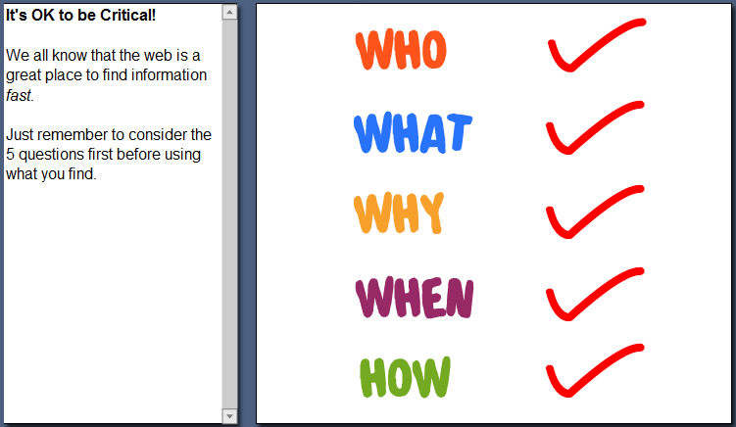

Now, as a class, evaluate this example:
New nose grown on man’s head
http://canadaam.ctvnews.ca/new-nose-grown-on-man-s-forehead-in-china-1.1471610

Next, divide class into groups of 3-4. Each group will evaluate a website and present it to class with a justification of why they think it’s good or bad. Other groups in the class can ask questions and challenge. Group prizes could be given.

Pg. 2 of this worksheet includes the URLs of websites to review; Pgs. 3 and 4 are worksheets to be given out to students to complete their evaluations on.
(Anything left handed and Cloning are good websites below; not others)

WEBSITES to give out to class groups for evaluation:
http://descy.50megs.com/Emankato/mankato.html

http://www.thedogisland.com/

http://www.anythinglefthanded.co.uk/

http://www.dhmo.org/

http://www.eurekascience.com/ICanDoThat/cloning.htm

http://www.molossia.org/countryeng.html

Evaluating Web Sites: Worksheet

Review one website using the following criteria, and justify to the class whether you think this web resource is likely to be good or not-so-good for academic research:

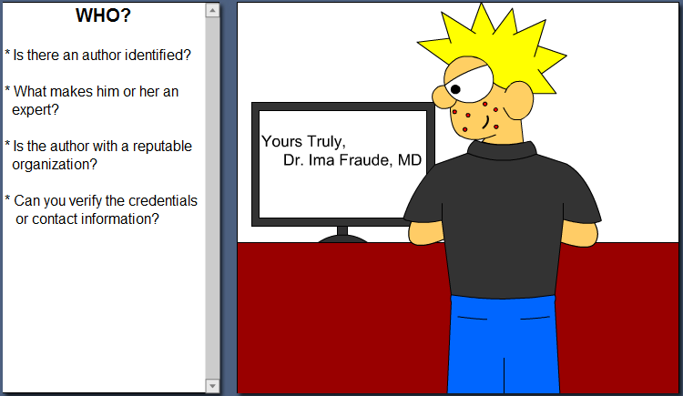
WHO has written this website (authors)?

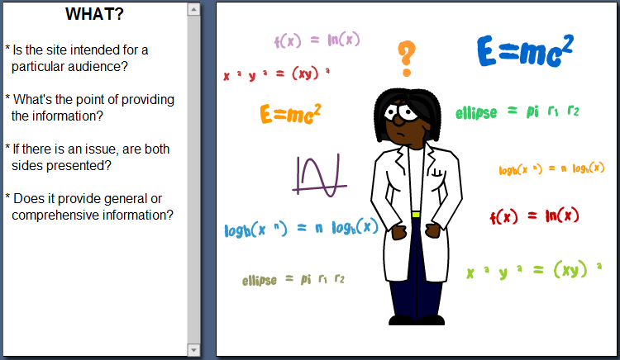
WHAT is this website about (purpose)?

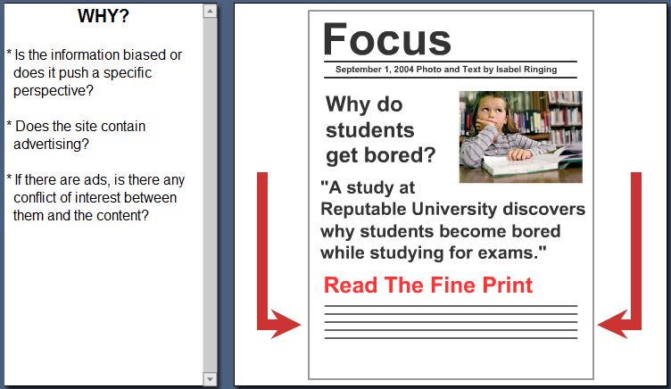
WHY – is it biased or balanced information?

Evaluating Web Sites: Worksheet

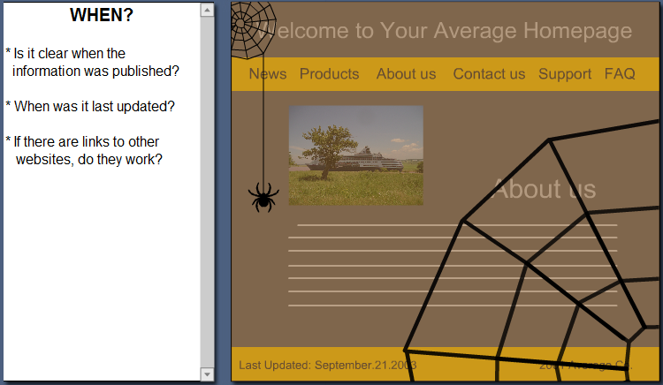
WHEN – how up to date is the information (currency)?

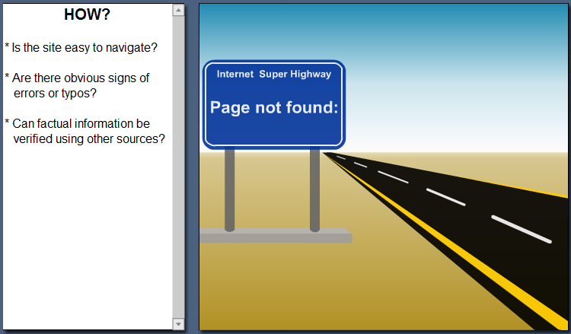
HOW does the website work (accuracy)?

EVALUATION SUMMARY?

* Be critical of information found on the web
*Determine credible and reliable sources by using 5 simple questions
*Use other credible sources of information found through the library

