Science
2013-2014
Mrs. Winters
lwinters@eesd.net

Welcome to Science!! I am looking forward to a fantastic year full of experiments, hands-on learning and life application. To do this, we will be using the California state standards as a guideline for our science class. Students will keep a copy of the standards in their binder so they can check on their progress towards mastering these standards.

Homework:
- There will not be much homework IF you work diligently in class (you determine your homework load!)
- For every day an assignment is late, 10% will be deducted from the grade. After 5 days late work WILL receive 50% and after the unit is finished work from that unit will NOT be accepted!
- I will be able to help most days after school, and during lunch if needed. My goal is for each student to succeed!

Classroom rules
- Prompt: Please be on time to class
2) Prepared: Please have your homework completed and the supplies you need for class EVERY day
3) Participate: Please be an active member of the class every day. You will get out of the class what you put into it.
4) Polite: Please be polite to each other by RESPECTING others' person, property, time, space and feelings.
5) Professional: School is your job. Please come to school dressed appropriately. Conduct yourself in a mature manner to have a safe and productive day

Materials
- Rigid safety glasses (Typically $1-$2 at Harbor Freight—avoid the soft goggles as they tend to fog up and the straps often fail. Students who already wear glasses do not need to buy safety goggles)
- Pencils and erasers (All science homework and classwork must be done in pencil)
- Pencil Sharpener with shaving catcher.
- Blue ball point pens (For correcting)
- College ruled notebook paper (A LOT)
- A Three ring binder—Please just get a simple 2” binder
- Colored Pencils
- 100 ruled 3x5 index cards
- 2-inch index card ring (Or any other way to organize the cards)
- USB-Flash Drive
- Book for SSR
- Scientific Calculator (There are some at the dollar tree by movies 8!!!)
- Optional: Please consider donating a Box of latex or Nitrile gloves (Costco carries Nitrile Gloves)
*If you are not able to purchase any of these materials please contact me! Thank you!

Consequences
In our life we live with many consequences. Consequences are just the good or bad outcome of an action. The following are the consequences should the rules be followed or broken.

If classroom rules are followed:

Praise (daily)
Positive notes/calls home (random)
Whole class radio time or preferred activity time (weekly)
Raffle tickets given to those following the rules (random) (every Friday drawing)
Class Party (once every trimester if 25 points are earned)
The joy of learning (each day of the school year)

If classroom rules are broken:
1st time--------Name on the chart (Warning and can’t win the drawing on Friday)
2nd time-------Check next to name (must stay 1 minute after class to talk with Mrs. Winters)

3rd time-------2 Checks next to name (Must stay 2 minutes after class)
*If 2 checks are received in one class period the next step is buddy room with a
reflection sheet.
4th time-------3 checks next to name (I will call home and student will serve a lunch detention)
5th time-------4 checks to name (this is defiant behavior and student will receive a citation)
**For more serious matters I reserve the right to follow school policy and give immediate citation, referral, or otherwise as laid out in the Boulder Creek policy manual.
*The chart is cleared at the end of every week to allow a fresh start.

Curriculum
- 7th Focus on Life Science, Glencoe Science
- 8th Focus on Physical Science, Glencoe Science

Science Grade Breakdown
Tests 30%  Quizzes 10%  Labs 20% | Participation/Binder Checks 10%  Projects/Science Articles 10%  Classwork/Homework 20%
Contact
Feel free to contact me with any questions or concerns! For me Email is better than voice mail!
Email: lwinters@eesd.net
Phone: 1-530-224-4140 (Boulder Creek)

Thank you for your time in reading this syllabus and I look forward to a productive fall semester with you! As long as all the rules are followed, we will absolutely have a fantastic semester.

Lisa Winters
Student signature____________________________________________ Date_____________

Parent signature____________________________________________ Date_____________
Year-at-a-Glance/Content
Trimester | 7th Grade Life Science | 8th Grade Physical Science
1 | - Cell Structure and Function  - Cell model  - Cell cycle and Division  - Levels of Cell Organization  - Reproduction of Organisms  - Genetics | - Motion  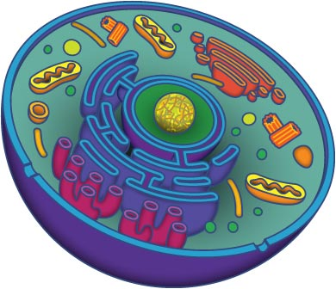  - Forces  - Bottle Rockets  - Density and Buoyancy  - Understanding the Atom  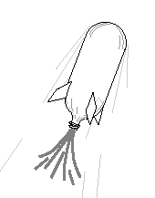  - Combining Atoms and Molecules  - States of matter
2 | - Natural Selection  - Adaption and Exctinction  - Fossils  - Rock Cycle and Fossils Board Game  - Plate Tectonics  - Classifying Organisms  - The Age of the Earth  - The History of Life on Earth | - The periodic table and Physical properties  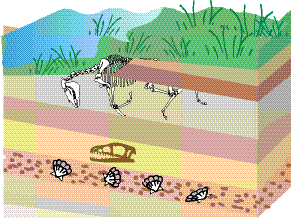  - Adopt and Element  - Chemical Reactions  - Acids and Bases in Solution  - Chemistry of Living Systems
3 | - Musculoskeletal system and Levers  - Cardiopulminary System and Pressure  - Life Size Model of Cardio-Pulminary System  - The Eye and Light  - The Ear and Sound  - The Human Reproductive System | - Structures of the Solar System  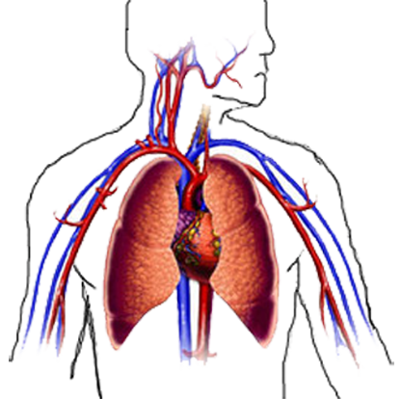  - Sun –Earth-Moon system  - The Planets and their Moons  - Create Your Own Solar System  - Asteroids, Comets and Meteoroids  - Stars and Galaxies

